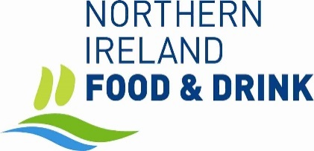

JOB DESCRIPTION: Business Support Assistant (Part time)

LOCATION: Belfast Mills, Percy Street, Belfast BT13 2HW (Hybrid)

REPORTS TO: Executive Director

Job Purpose:

To provide all-round administrative support to both the Executive Director and Board of Directors.

To support NIFDA member growth.

To take responsibility for office management, project management, deadline compliance and security of documents and files.

Responsibilities:

- Be a point of contact with customers, handling enquiries and complaints aiming to provide excellent service always.
- Schedule Board meetings, prepare meeting agendas, papers, take minutes during meetings and distribute to Board members.
- Provide administrative support to the Director and manage various cluster groups.
- Maintain office correspondence including crafting routine letters and documents.
- Assist in event management for the various public and private NIFDA Events.
- Maintain and develop NIFDA databases.
- Maintain and develop the NIFDA portal (www.nifda.co.uk)
- Solve simple IT problems liaising with support provider as required.
- Maintain electronic filing system, ensuring processes and software are up to date, in working order and compliant with Data Protection legislation.
- Assist with key projects as directed.
- Liaise with outside agencies and governmental bodies on various projects.

PERSON SPECIFICATION:

Qualifications: a minimum of

- 5 GCSE’s (grades A-C), or equivalent

- At least three years’ experience providing executive-level support to a management board or committee is highly desirable but not essential if the candidate can demonstrate the appropriate skills & qualities required.
- Experience or knowledge of the food and drink industry or related sectors is highly desirable.

Competencies – In addition to the minimum requirements outlined above, the post holder will be able to demonstrate the following:
- Executive support experience.
- Confidentiality and discretion.
- Good telephone manner, remaining professional in all circumstances.
- Administration, organisational and clerical skills.
- Clear communication skills, multi-tasking capability and professionalism.
- Excellent Working knowledge of Microsoft Office.
- Good working knowledge of social media platforms.
- Confidence, flexibility, self-motivation and persistence.
- Ability to work on own initiative.
- Ability to prioritise.
- Attention to detail, accuracy, efficiency and good time-keeping.
- Motivation to achieve work objectives in line with the requirements of the Board.
- Willingness to gain new skills and knowledge to achieve ongoing self-improvement.

The candidate must occasionally be willing to work outside office hours, e.g. early morning Board / Industry meetings and events which are held late into the evenings.

Outline Terms and Conditions

- Total working hours 15, over the period Monday to Friday (flexible)
- Probationary period of six months
- Company pension scheme membership (contributory)
- Company Sick Pay Scheme (following qualifying period)
- The role will be hybrid but using the office base when necessary, subject to business needs being met.
- Office parking on-site (free)
- 25 days annual leave + 11 Statutory days (pro-rata to hours worked)
- Salary £29500, (pro-rata to hours worked)

